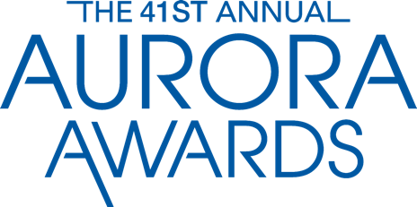

Photography Release

By submitting photos, you agree that the FHBA & Aurora Awards has the right to publish them in its own materials, including on its website, and to provide them to other media publishing stories on Aurora winners, finalists, or the Aurora awards program. It is the responsibility of the applicant to have secured permission from their photographers for FHBA & Aurora Awards to use their photographs.
By signing this release form, you warrant that you have provided permission to Aurora Awards to use these photos in the manner of its choice, including in the awards ceremony, promotional materials, in articles about the awards, and on its website. You also warrant that you have the authority to grant this permission.

ENTRY NUMBER

Photographer Name:

Address:

City: State: Zip Code:

Phone: E-mail:

Your Name: Entry #

Signature: Date:

Please fill out this form completely, and return with entry submittal.

